In osmosis water molecules move from area of _______ to _______ through semipermeable membrane
A. Higher solute concentration to lower solute concentration
B. Lower solute concentration to higher solute concentration
C. Lower solvent concentration to higher solvent concentration
D. All of these
ANSWER: B
The solution with the higher solute concentration is
A. Hypotonic
B. Hypertonic
C. Isotonic
D. None of these
ANSWER: B
The solution with the lower solute concentration is
A. Hypotonic
B. Hypertonic
C. Isotonic
D. None of these
ANSWER: A
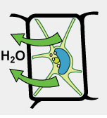
Identify effect of _________solution on plant cell
A. Hypotonic
B. Hypertonic
C. Isotonic
D. None of these
ANSWER: B
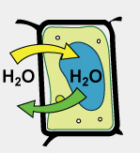
Identify effect of _________solution on plant cell
A. Hypotonic
B. Hypertonic
C. Isotonic
D. None of these
ANSWER: C
In ________________conditions a plant cell loses water and cytoplasm shrinks and shrinkage of cytoplasm is called plasmolysis.
A. Hypotonic
B. Hypertonic
C. Isotonic
D. None of these
ANSWER: B
_________________is the movement of substances against a concentration gradient.
A. Active transport
B. Facilitated diffusion
C. Diffusion
D. Osmosis
ANSWER: A
Movement across the membranes occurs by:
A. Diffusion and Osmosis
B. Facilitated Diffusion
C. Active Transport
D. All of these
ANSWER: D
In _______________, molecules diffuse across the plasma membrane with assistance from membrane proteins, such as channels and carriers
A. Diffusion
B. Osmosis
C. Facilitated Diffusion
D. None of these
ANSWER: C
In biological systems, the form in which energy occurs is:
A. ATP
B. Adenosine Triphosphate
C. Both A and B
D. None of these
ANSWER: C
The process which require energy input is:
A. Diffusion
B. Active transport
C. Facilitated Diffusion
D. Osmosis
ANSWER: B
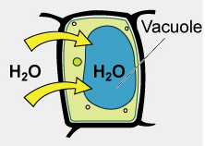
Identify effect of _________solution on plant cell
A. Hypotonic
B. Hypertonic
C. Isotonic
D. None of these
ANSWER: A
What would happen to red blood cells in a hypotonic solution?
A. They would shrink due to osmotic water loss
B. They would rupture due to the influx of water
C. They would swell but avoid rupturing due to the cell wall
D. They would retain their shape due to the cell wall
ANSWER: B
Plant cells swell up when kept in a:
A. Hypotonic solution
B. Hypertonic solution
C. Isotonic solution
D. None of these
ANSWER: A
Plant cells do not burst in distilled water, because of the:
A. Presence of cell membrane
B. Absence of cell wall
C. Presence of cell wall
D. Cell wall is not permeable
ANSWER: C

F

